**Quotation.jsp**

<%@ page language=*"java"* contentType=*"text/html; charset=ISO-8859-1"* pageEncoding=*"ISO-8859-1"*%>

<!DOCTYPE html PUBLIC "-//W3C//DTD XHTML 1.0 Transitional//EN" "http://www.w3.org/TR/xhtml1/DTD/xhtml1-transitional.dtd">

<html xmlns=*"http://www.w3.org/1999/xhtml"*>

<head>

<meta http-equiv=*"Content-Type"* content=*"text/html; charset=iso-8859-1"* />

<title>FIRE INSURANCE</title>

</head>

<body>

<h3 align=*"center"*>NSURE FIRE INSURANCE</h3>

<fieldset><legend>Account Code/ Branch Details</legend>

<table width=*"1099"* border=*"0"*>

<tr>

<td>Source Type *: </td>

<td>&nbsp;</td>

<td><select name=*"select"*>

<option>---PLEASE SELECT----</option>

</select></td>

<td>Branch *: </td>

<td>&nbsp;</td>

<td><select name=*"select2"*>

<option value=*"0"*>---PLEASE SELECT---</option>

<option value=*"1"*>HEAD QUATERS</option>

<option value=*"2"*>COIMBATORE</option>

</select></td>

</tr>

<tr>

<td width=*"176"*>AccountType*:</td>

<td width=*"111"*>&nbsp;</td>

<td width=*"265"*><label>

<input type=*"text"* name=*"textfield"* />

</label></td>

<td width=*"189"*>Agent Name: </td>

<td width=*"87"*>&nbsp;</td>

<td width=*"245"*><label>

<br />

<input type=*"text"* name=*"textfield2"* />

</label></td>

</tr>

<tr>

<td>Contact Type : </td>

<td>&nbsp;</td>

<td>

<select name=*"select3"* class=*"form-control"* ng-model=*"drpContactType"*>

<option value=*"1"*>Individual</option>

<option value=*"2"*>Business</option>

<option value=*"3"*>Others</option>

</select> </td>

<td>&nbsp;</td>

</tr>

</table>

</form>

</fieldset>

<form action=*""* class=*"form-horizontal"* ng-if=*"drpContactType=='3'"* method=*"post"*>

<fieldset>

<legend>Client Details</legend>

<table width=*"1264"* border=*"0"*>

<tr>

<td>Name:</td>

<td>&nbsp;</td>

<td><input type=*"text"* name=*"textfield3"* /></td>

<td>&nbsp;</td>

<td colspan=*"3"* rowspan=*"10"*><fieldset>

<legend> Permanent Address</legend>

<table width=*"394"* border=*"0"*>

<tr>

<td width=*"92"*>Address</td>

<td width=*"96"*>&nbsp;</td>

<td width=*"192"*><form id=*"form8"* name=*"form8"* method=*"post"* action=*""*>

<label>

<input type=*"text"* name=*"textfield10"* />

</label>

</form> </td>

</tr>

<tr>

<td>&nbsp;</td>

<td>&nbsp;</td>

<td><input type=*"text"* name=*"textfield99"* /></td>

</tr>

<tr>

<td>&nbsp;</td>

<td>&nbsp;</td>

<td><input type=*"text"* name=*"textfield910"* /></td>

</tr>

<tr>

<td>&nbsp;</td>

<td>&nbsp;</td>

<td><input type=*"text"* name=*"textfield911"* /></td>

</tr>

<tr>

<td>PostCode:</td>

<td><input name=*"textfield912"* type=*"text"* value=*"xxx"* maxlength=*"6"* /></td>

<td><input type=*"text"* name=*"textfield913"* /></td>

</tr>

<tr>

<td>State/Country: </td>

<td>&nbsp;</td>

<td><label>

<select name=*"select12"*>

</select>

</label></td>

</tr>

<tr>

<td>Country Code: </td>

<td>&nbsp;</td>

<td><label>

<select name=*"select13"*>

</select>

</label></td>

</tr>

</table>

<p>&nbsp;</p>

</fieldset> </td>

</tr>

<tr>

<td width=*"247"*>Name:</td>

<td width=*"128"*>&nbsp;</td>

<td width=*"144"*><form id=*"form2"* name=*"form2"* method=*"post"* action=*""*>

<label></label>

<label>

<input type=*"text"* name=*"textfield4"* />

</label>

</form> </td>

<td width=*"144"*>&nbsp;</td>

</tr>

<tr>

<td>New Ic No: </td>

<td>&nbsp;</td>

<td><form id=*"form3"* name=*"form3"* method=*"post"* action=*""*>

<label>

<input type=*"text"* name=*"textfield5"* />

</label>

</form> </td>

<td>&nbsp;</td>

</tr>

<tr>

<td>Old IC No/Passport No/Uniform Personnel Id: </td>

<td>&nbsp;</td>

<td><form id=*"form4"* name=*"form4"* method=*"post"* action=*""*>

<label>

<input type=*"text"* name=*"textfield6"* />

</label>

</form> </td>

<td>&nbsp;</td>

</tr>

<tr>

<td>Salutation:</td>

<td>&nbsp;</td>

<td><form id=*"form5"* name=*"form5"* method=*"post"* action=*""*>

<label></label>

<label>

<select name=*"select4"*>

</select>

</label>

</form> </td>

<td>&nbsp;</td>

</tr>

<tr>

<td>Name:</td>

<td>&nbsp;</td>

<td><input type=*"text"* name=*"textfield7"* /></td>

<td>&nbsp;</td>

</tr>

<tr>

<td>Nationality:</td>

<td>&nbsp;</td>

<td><select name=*"select5"*>

</select></td>

<td>&nbsp;</td>

</tr>

<tr>

<td>Race:</td>

<td>&nbsp;</td>

<td><select name=*"select6"*>

</select></td>

<td>&nbsp;</td>

</tr>

<tr>

<td height=*"37"*>Date of Birth: </td>

<td>&nbsp;</td>

<td><label>

<input type=*"text"* name=*"textfield8"* />

</label></td>

<td>&nbsp;</td>

</tr>

<tr>

<td>Gender:</td>

<td>&nbsp;</td>

<td><select name=*"select7"*>

</select></td>

<td>&nbsp;</td>

<td colspan=*"3"*>&nbsp;</td>

</tr>

<tr>

<td>Trade/Occupation:</td>

<td>&nbsp;</td>

<td><select name=*"select8"*>

</select></td>

<td>&nbsp;</td>

<td colspan=*"3"* rowspan=*"12"*><fieldset><legend>Correspondence Address</legend>

<table width=*"434"* border=*"0"*>

<tr>

<td width=*"151"*>Address:</td>

<td width=*"69"*>&nbsp;</td>

<td width=*"117"*><input type=*"text"* name=*"textfield102"* /></td>

</tr>

<tr>

<td>&nbsp;</td>

<td>&nbsp;</td>

<td><input type=*"text"* name=*"textfield103"* /></td>

</tr>

<tr>

<td>&nbsp;</td>

<td>&nbsp;</td>

<td><input type=*"text"* name=*"textfield104"* /></td>

</tr>

<tr>

<td>&nbsp;</td>

<td>&nbsp;</td>

<td><input type=*"text"* name=*"textfield105"* /></td>

</tr>

<tr>

<td>PostCode:</td>

<td>&nbsp;</td>

<td><input type=*"text"* name=*"textfield106"* /></td>

</tr>

<tr>

<td>State/Country:</td>

<td>&nbsp;</td>

<td><select name=*"select14"*>

</select></td>

</tr>

<tr>

<td>Country Code:</td>

<td>&nbsp;</td>

<td><select name=*"select15"*>

</select></td>

</tr>

</table>

<p>&nbsp;</p>

<p>&nbsp;</p>

</fieldset> </td>

</tr>

<tr>

<td height=*"31"*>Marital Status: </td>

<td>&nbsp;</td>

<td><select name=*"select9"*>

</select></td>

<td>&nbsp;</td>

</tr>

<tr>

<td>No.Of.Family Members: </td>

<td>&nbsp;</td>

<td><form id=*"form6"* name=*"form6"* method=*"post"* action=*""*>

<label>

<input type=*"text"* name=*"textfield9"* />

</label>

</form> </td>

<td>&nbsp;</td>

</tr>

<tr>

<td>Income Range: </td>

<td>&nbsp;</td>

<td><select name=*"select10"*>

</select></td>

<td>&nbsp;</td>

</tr>

<tr>

<td>V.I.P Status: </td>

<td>&nbsp;</td>

<td><form id=*"form7"* name=*"form7"* method=*"post"* action=*""*>

<label>

<input name=*"radiobutton"* type=*"radio"* value=*"radiobutton"* />

Yes </label>

<label>

<input name=*"radiobutton"* type=*"radio"* value=*"radiobutton"* />

No </label>

</form> </td>

<td>&nbsp;</td>

</tr>

<tr>

<td>Staff Id: </td>

<td>&nbsp;</td>

<td><label>

<input name=*"radiobutton"* type=*"radio"* value=*"radiobutton"* />

Yes </label>

<label>

<input name=*"radiobutton"* type=*"radio"* value=*"radiobutton"* />

No </label></td>

<td>&nbsp;</td>

</tr>

<tr>

<td>GST Registered: </td>

<td>&nbsp;</td>

<td><label>

<input name=*"radiobutton"* type=*"radio"* value=*"radiobutton"* />

Yes </label>

<label>

<input name=*"radiobutton"* type=*"radio"* value=*"radiobutton"* />

No </label></td>

<td>&nbsp;</td>

</tr>

<tr>

<td height=*"29"*>GST Registration No: </td>

<td>&nbsp;</td>

<td><input type=*"text"* name=*"textfield92"* /></td>

<td>&nbsp;</td>

</tr>

<tr>

<td>GST Reg Date: </td>

<td>&nbsp;</td>

<td><input type=*"text"* name=*"textfield94"* /></td>

<td>&nbsp;</td>

</tr>

<tr>

<td>GST Expiry Date: </td>

<td>&nbsp;</td>

<td><input type=*"text"* name=*"textfield93"* /></td>

<td>&nbsp;</td>

</tr>

<tr>

<td>Campaign Code: </td>

<td>&nbsp;</td>

<td><select name=*"select11"*>

</select></td>

<td>&nbsp;</td>

</tr>

<tr>

<td>Website</td>

<td>&nbsp;</td>

<td><input type=*"text"* name=*"textfield95"* /></td>

<td>&nbsp;</td>

</tr>

<tr>

<td>Facebook URL: </td>

<td>&nbsp;</td>

<td><input type=*"text"* name=*"textfield96"* /></td>

<td>&nbsp;</td>

<td width=*"92"*>Tel.No(House)</td>

<td width=*"115"*>&nbsp;</td>

<td width=*"512"*><input type=*"text"* name=*"textfield1062"* /></td>

</tr>

<tr>

<td>Mobile No: </td>

<td>&nbsp;</td>

<td><input type=*"text"* name=*"textfield97"* /></td>

<td>&nbsp;</td>

<td>Tel No(Office) </td>

<td>&nbsp;</td>

<td><input type=*"text"* name=*"textfield1063"* /></td>

</tr>

<tr>

<td>E-Mail</td>

<td>&nbsp;</td>

<td><input type=*"text"* name=*"textfield98"* /></td>

<td>&nbsp;</td>

<td>Fax No(House)</td>

<td>&nbsp;</td>

<td><input type=*"text"* name=*"textfield10632"* /></td>

</tr>

<tr>

<td>&nbsp;</td>

<td>&nbsp;</td>

<td>&nbsp;</td>

<td>&nbsp;</td>

<td>Fax No (Office)</td>

<td>&nbsp;</td>

<td><input type=*"text"* name=*"textfield10633"* /></td>

</tr>

<tr>

<td>&nbsp;</td>

<td>&nbsp;</td>

<td>&nbsp;</td>

<td>&nbsp;</td>

<td>Remarks:</td>

<td>&nbsp;</td>

<td><form id=*"form9"* name=*"form9"* method=*"post"* action=*""*>

<label>

<textarea name=*"textarea"*></textarea>

</label>

</form> </td>

</tr>

</table>

<fieldset>

<table width=*"1153"* border=*"0"*>

<tr>

<td width=*"380"*>Personal Data Production consent Signed by Customer: </td>

<td width=*"188"*>*</td>

<td width=*"571"*><label>

<input name=*"radiobutton"* type=*"radio"* value=*"radiobutton"* />

Yes </label>

<label>

<input name=*"radiobutton"* type=*"radio"* value=*"radiobutton"* />

No </label></td>

</tr>

<tr>

<td>Consent on Cross Selling signed by customer </td>

<td>*</td>

<td><label>

<input name=*"radiobutton"* type=*"radio"* value=*"radiobutton"* />

Yes </label>

<label>

<input name=*"radiobutton"* type=*"radio"* value=*"radiobutton"* />

No </label></td>

</tr>

</table>

</fieldset>

<p>&nbsp;</p>

<table width=*"1159"* border=*"0"*>

<tr>

<td width=*"513"*>&nbsp;</td>

<td width=*"48"*>

<label>

<input type=*"submit"* name=*"Submit"* value=*"Reset"* />

</label>

</td>

<td width=*"52"*>

</td>

<td width=*"528"*>&nbsp;</td>

</tr>

</table>

</form>

<button onclick="window.location.href='http://localhost:8087/Controls/next.jsp'" >Next</button>

</body>

</html>

**SCREENSHOT**

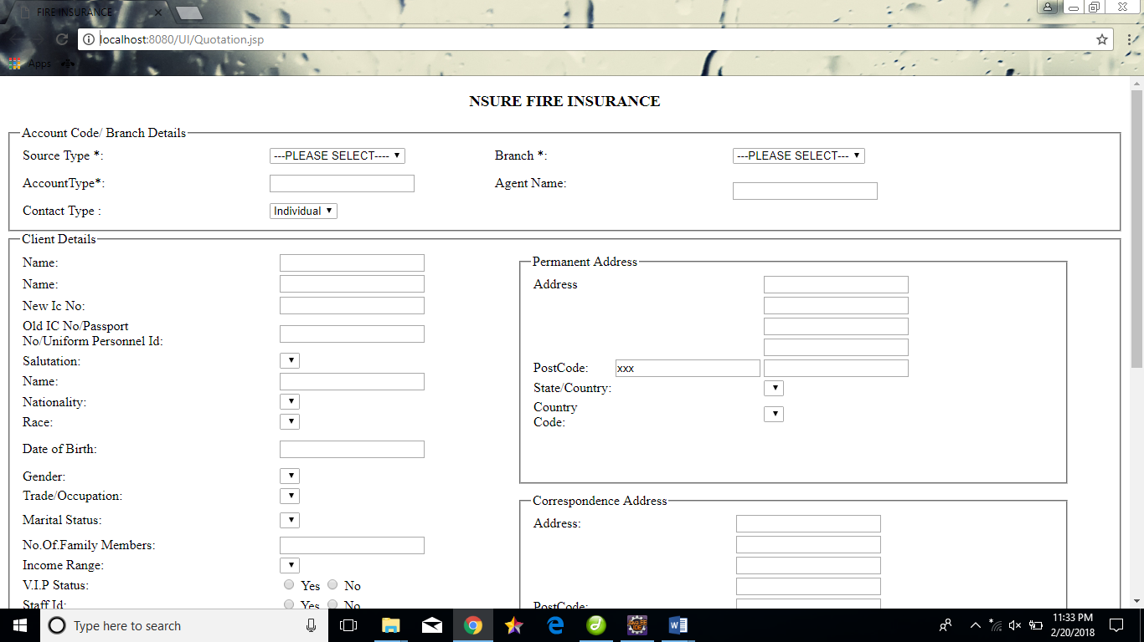

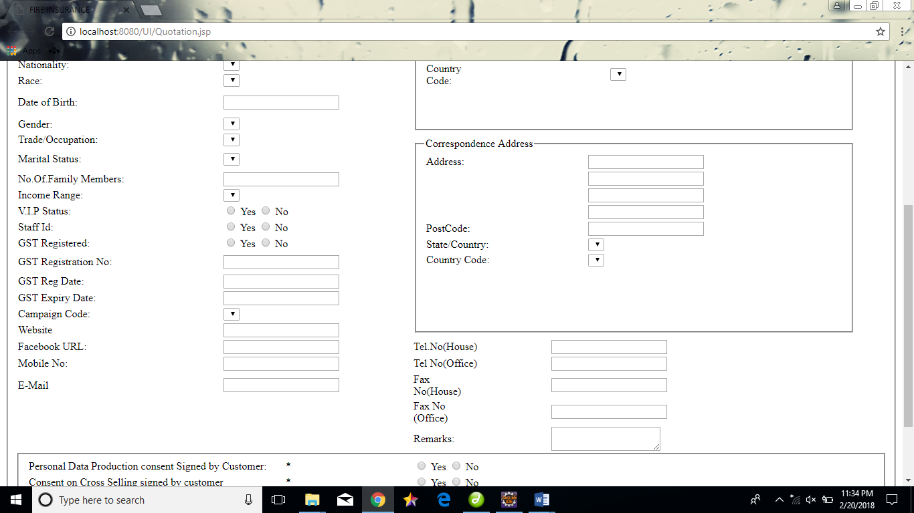

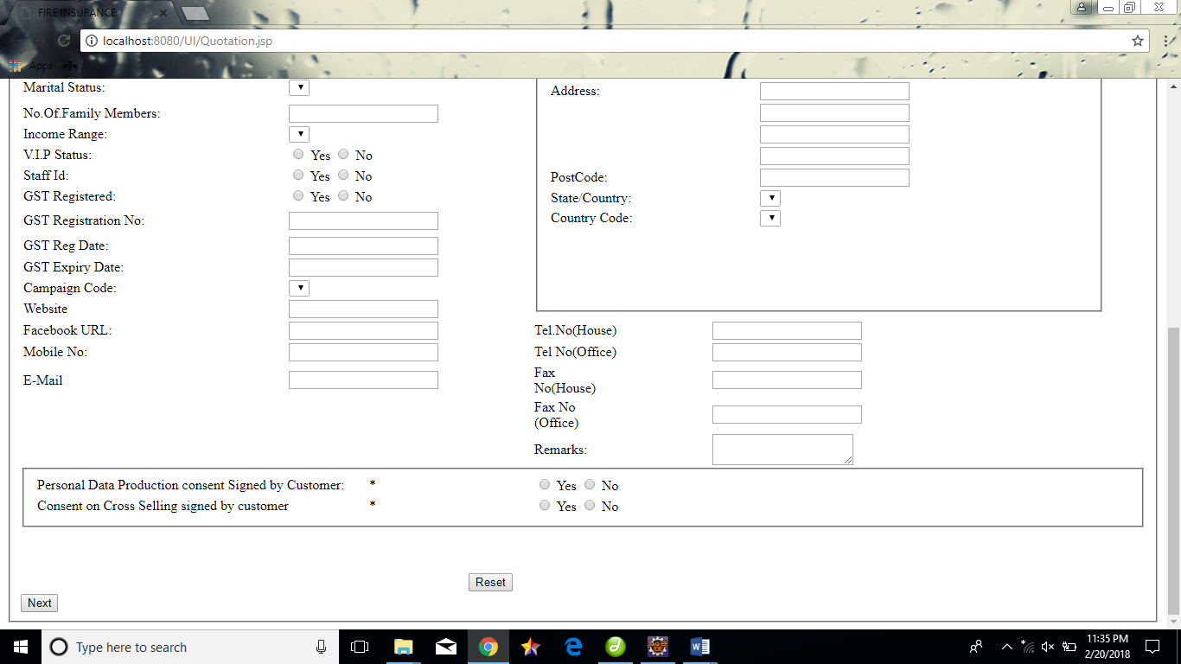

**Schedule.jsp**

<%@ page language=*"java"* contentType=*"text/html; charset=ISO-8859-1"*

pageEncoding=*"ISO-8859-1"*%>

<!DOCTYPE html PUBLIC "-//W3C//DTD HTML 4.01 Transitional//EN" "http://www.w3.org/TR/html4/loose.dtd">

<html ng-app=*"schedule"*>

<head lang=*"en"*>

<meta http-equiv=*"Content-Type"* content=*"text/html; charset=ISO-8859-1"*>

<title>SCHEDULE DETAILS</title>

<meta charset=*"utf-8"*>

<title>SCHEDULE DETAILS</title>

<link rel=*"stylesheet"* type=*"text/css"* href=*"ng-grid.min.css"* />

<link rel=*"stylesheet"* type=*"text/css"* href=*"style.css"* />

<script type=*"text/javascript"*

src=*"http://code.jquery.com/jquery-1.8.2.js"*></script>

<script type=*"text/javascript"*

src=*"https://ajax.googleapis.com/ajax/libs/angularjs/1.2.23/angular.min.js"*></script>

<script src=*"ng-grid-2.0.11.min.js"*></script>

<script type=*"text/javascript"* src=*"schedule.js"*></script>

<style type=*"text/css"*>

*.gridStyle* {

width: *1000px*;

height: *800px*

}

*.ngGrid* {

background-color: *#fdfdfd*

}

*.ngGrid* **input**[type="checkbox"] {

margin: *0*;

padding: *0*

}

*.ngGrid* **input** {

vertical-align: *top*

}

*.ngViewport* {

overflow: *auto*;

min-height: *20px*

}

*.ngViewport:focus* {

outline: *0*

}

*.ngCanvas* {

position: *relative*

}

*.ngVerticalBar* {

position: *absolute*;

right: *0*;

width: *0*

}

*.ngVerticalBarVisible* {

width: *1px*;

background-color: *#d4d4d4*

}

*#testDataLength* {

position: *absolute*;

top: *0*;

right: *0*;

z-index: *-100000*

}

*.ngHeaderContainer* {

position: *relative*;

overflow: *hidden*;

font-weight: *bold*;

background-color: *inherit*

}

*.ngHeaderCell* {

position: *absolute*;

top: *0*;

bottom: *0*;

background-color: *inherit*

}

*.ngTopPanel* {

position: *relative*;

z-index: *1*;

background-color: *#eaeaea*;

border-bottom: *1px solid #d4d4d4*

}

*.ngRow* {

position: *absolute*;

border-bottom: *1px solid #d4d4d4*

}

*.ngRow.odd* {

background-color: *#fdfdfd*

}

*.ngRow.even* {

background-color: *#f3f3f3*

}

*.ngRow.selected* {

background-color: *#c9dde1*

}

*.ngCell* {

overflow: *hidden*;

position: *absolute*;

top: *0*;

bottom: *0*;

background-color: *inherit*

}

*.ngCell.pinned* {

z-index: *1*

}

*.ngCellText* {

padding: *5px*;

-moz-box-sizing: *border-box*;

-webkit-box-sizing: *border-box*;

box-sizing: *border-box*;

white-space: *nowrap*;

-ms-text-overflow: *ellipsis*;

-o-text-overflow: *ellipsis*;

text-overflow: *ellipsis*;

overflow: *hidden*

}

*.ngRow.canSelect* {

cursor: *pointer*

}

</style>

</head>

<body ng-controller=*"ctrl"*>

<style>

**p** {

font-family: *"Times New Roman"*;

}

**body** {

width: *60%*;

font-size: *16px*;

background-color: *#f2f2f2*;

background-position: *10px 10px*;

background-repeat: *no-repeat*;

}

**label***.field* {

text-align: *right*;

width: *80%*;

}

**input**[type="text"] {

width: *60%*;

box-sizing: *border-box*;

border: *2px solid #ccc*;

border-radius: *3px*;

font-size: *16px*;

background-color: *#f2f2f2*;

background-position: *20px 20px*;

background-repeat: *no-repeat*;

}

*.val* {

width: *80%*;

font-size: *16px*;

background-color: *#f2f2f2*;

background-position: *10px 10px*;

background-repeat: *no-repeat*;

}

</style>

</head>

<body>

<script

src=*"https://ajax.googleapis.com/ajax/libs/angularjs/1.6.4/angular.min.js"*></script>

<h3>SCHEDULE DETAILS-NEW BUSINESS</h3>

<fieldset>

<div class=*"val"*>

<fieldset>

<legend>

<h4>PERIOD OF COVER DETAILS</h4>

</legend>

<table>

<table width=*"825"*>

<tr>

<td><label class=*"field"*>Inception Date * :</label></td>

<td><input name=*"search2"* type=*"date"* id=*"mySearch"*

placeholder=*""* /></td>

<td width=*"200"*>Premium rate type * :</td>

<td width=*"273"*><input name=*"text4"* type=*"text"*

ng-model=*"premium rate type"* /></td>

</tr>

<tr>

<td width=*"200"*>Issued Date * :</td>

<td width=*"273"*><input name=*"text4"* type=*"date"*

ng-model=*"issued date"* /></td>

<td width=*"139"*>Expiry Date * :</td>

<td width=*"240"*><input name=*"text10"* type=*"date"*

ng-model=*"expiry date"* /></td>

</tr>

</table>

</fieldset>

<fieldset>

<legend>

<h4>SCHEDULE DETAILS</h4>

</legend>

<fieldset>

<legend>

<h4>Situation of risk:</h4>

</legend>

<table>

<tr>

<td>

<table width=*"825"*>

<tr>

<td width=*"200"*>House number * :</td>

<td width=*"273"*><input name=*"text4"* type=*"text"*

ng-model=*"house number"* /></td>

<td width=*"139"*>Floor number * :</td>

<td width=*"240"*><input name=*"text10"* type=*"text"*

ng-model=*"floor number"* /></td>

</tr>

<tr>

<td>Building number/ Building Name * :</td>

<td><input name=*"text5"* type=*"text"*

ng-model=*"building name"* /></td>

<td>Street name * :</td>

<td><input name=*"text11"* type=*"text"*

ng-model=*"street name"* /></td>

</tr>

<tr>

<td>Area/ Housing Name * :</td>

<td><input name=*"text14"* type=*"text"*

ng-model=*"area housing name"* /></td>

<td>Post Code * :</td>

<td><input name=*"text13"* type=*"text"*

ng-model=*"Post Code"* /></td>

</tr>

<tr>

<td>Town * :</td>

<td><input name=*"text6"* type=*"text"* ng-model=*"town"* /></td>

<td>State * :</td>

<td><select name=*"select4"* ng-model=*"State"*

required=*"required"*>

<option value=*""*>--Please Select--</option>

<option value=*"Tamilnadu "*>TAMILNADU</option>

<option value=*"Kerala"*>KERALA</option>

<option value=*"Karnataka"*>KARNATAKA</option>

<option value=*"Maharastra"*>MAHARASTRA</option>

</select></td>

</tr>

<tr>

<td>Country * :</td>

<td><select name=*"select4"* ng-model=*"State"*

required=*"required"*>

<option value=*""*>--Please Select--</option>

<option value=*"Malaysia "*>MALAYSIA</option>

<option value=*"India"*>INDIA</option>

<option value=*"Singapore"*>SINGAPORE</option>

<option value=*"UK"*>UK</option>

<option value=*"USA"*>USA</option>

</select></td>

<td>Risk Code * :</td>

<td><input name=*"text13"* type=*"text"*

ng-model=*"Risk Code"* /></td>

</tr>

</table>

</fieldset>

<fieldset>

<legend><h4>Building and other details</h4></legend>

<table>

<tr>

<td>

<table width=*"825"*>

<tr>

<td>Wall * :</td>

<td><select name=*"select4"* ng-model=*"Wall"*required=*"required"*>

<option value=*""*>--Please Select--</option>

<option value=*"Masonry walls"*>MASONRY WALLS</option>

<option value=*"Light partition walls"*>LIGHT PARTITION WALLS</option>

</select></td>

<td>Roof * :</td>

<td><select name=*"select4"* ng-model=*"Roof"*required=*"required"*>

<option value=*""*>--Please Select--</option>

<option value=*"Bitumen roofing"*>BITUMEN ROOFING</option>

<option value=*"Liquid membance"*>LIQUID MEMBANCE</option>

<option value=*"Single ply roofing"*>SINGLE PLY ROOFING</option>

<option value=*"Green roofs"*>GREEN ROOFS</option>

</select></td>

</tr>

<tr>

<td>Floor * :</td>

<td><select name=*"select4"* ng-model=*"Floor"*required=*"required"*>

<option value=*""*>--Please Select--</option>

<option value=*"Ceramic Tile"*>Ceramic Tile</option>

<option value=*"Hardwood flooring"*>Hardwood Flooring</option>

<option value=*"Laminate flooring"*>Laminate Flooring</option>

<option value=*"Marble flooring"*>Marble Flooring</option>

<option value=*"Cork flooring"*>Cork Flooring</option>

<option value=*"Bamboo flooring"*>Bamboo Flooring</option>

</select></td>

<td>Type of building * :</td>

<td><select name=*"select4"* ng-model=*"Type of building"*required=*"required"*>

<option value=*""*>--Please Select--</option>

<option value=*"Ceramic Tile"*>Concerete</option>

<option value=*"Hardwood flooring"*>Cement sheet</option>

</select></td>

</tr>

<tr>

Is the building with open site attached to it with floor area :<input name=*"text14"* type=*"text"* ng-model=*"attached type"* />

</tr>

<tr>

<td>Protection Code * :</td>

<td><select name=*"select4"* ng-model=*"protection code"*required=*"required"*>

<option value=*""*>--Please Select--</option>

<option value=*"1010"*>1010</option>

<option value=*"1011"*>1011</option>

<option value=*"1012"*>1012</option>

<option value=*"1013"*>1013</option>

</select></td>

<td>Section * :</td>

<td><select name=*"select4"* ng-model=*"protection code"*required=*"required"*>

<option value=*""*>--Please Select--</option>

<option value=*"A"*>A</option>

<option value=*"B"*>B</option>

<option value=*"C"*>C</option>

<option value=*"D"*>D</option>

</select></td>

</tr>

<tr>

<td>Major Occupation * :</td>

<td><select name=*"select4"* ng-model=*"State"*

required=*"required"*>

<option value=*""*>--Please Select--</option>

</select></td>

<td>Trade Occupation * :</td>

<td><select name=*"select4"* ng-model=*"State"*

required=*"required"*>

<option value=*""*>--Please Select--</option>

</select></td>

</tr>

<tr>

<td>PIAM code * :</td>

<td><select name=*"select4"* ng-model=*"Piam code"*

required=*"required"*>

<option value=*""*>--Please Select--</option>

</select></td>

<td>Occupied as * :</td>

<td><input name=*"text13"* type=*"text"*

ng-model=*"Occupied as"* /></td>

</tr>

<tr>

<td>Year constructed * :</td>

<td><input name=*"text13"* type=*"text"*

ng-model=*"Year constructed"* /></td>

<td>Number of storey * :</td>

<td><input name=*"text13"* type=*"text"*

ng-model=*"number of storey"* /></td>

</tr>

<tr>

<td>Construction class code * :</td>

<td><input name=*"text13"* type=*"text"*

ng-model=*"construction class code"* /></td>

<td>Construction class code % * :</td>

<td><input name=*"text13"* type=*"text"*

ng-model=*"construction class code %"* /></td>

</tr>

</table>

</fieldset>

</fieldset>

<tr>

<td><button

>BACK</button></td>

<td>&nbsp;</td>

<td><button

>NEXT</button></td>

</tr>

</body>

</html>

**SCREENSHOT**

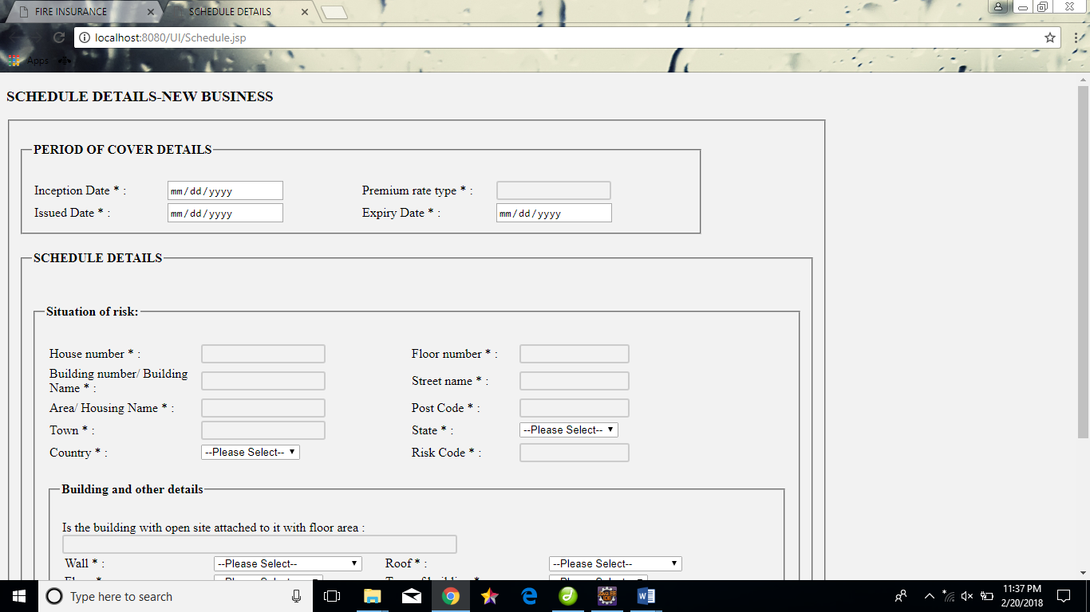

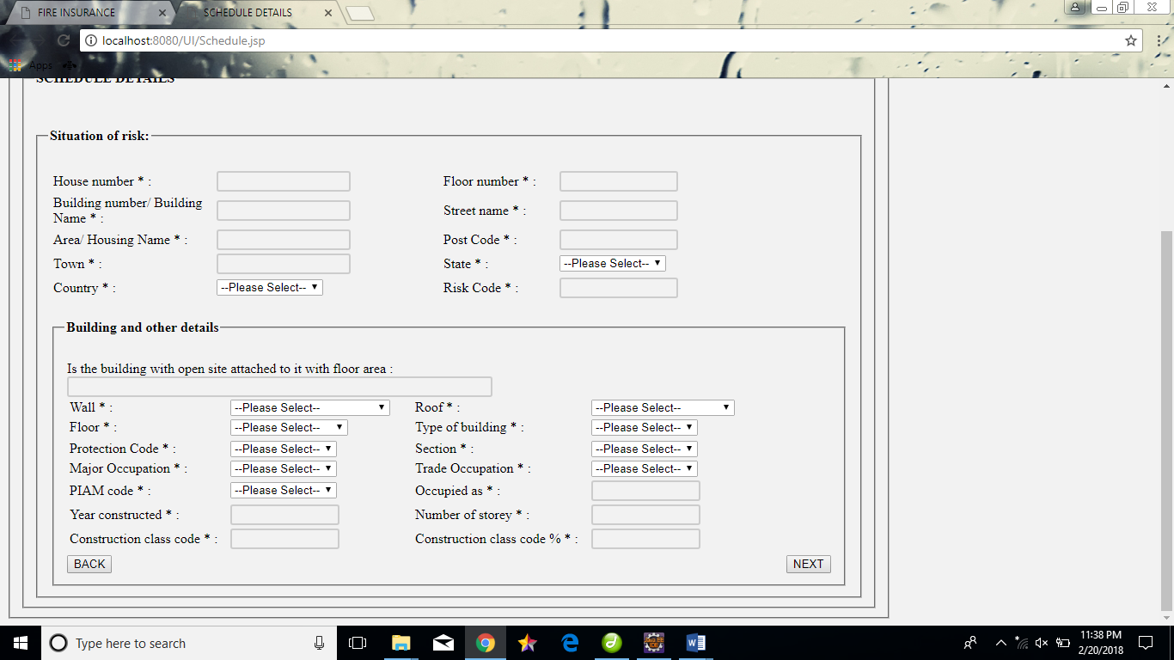

**Proposal.jsp**

<!DOCTYPE html PUBLIC "-//W3C//DTD HTML 4.01 Transitional//EN" "http://www.w3.org/TR/html4/loose.dtd">

<html xmlns=*"http://www.w3.org/1999/xhtml"*>

<head>

<meta http-equiv=*"Content-Type"* content=*"text/html; charset=iso-8859-1"* />

<title>PROPOSAL FORM DECLARATION</title>

<script type=*"text/javascript"*>

**function** validate()

{

**if**( document.myForm.textfield3.value == "" )

{

alert( "Please fill all the fields!" );

document.myForm.textfield3.focus() ;

**return** **false**;

}

**if**( document.myForm.textfield32.value == "" )

{

alert( "Please fill all the fields!" );

document.myForm.textfield32.focus() ;

**return** **false**;

}

**if**( document.myForm.textfield33.value == "" )

{

alert( "Please fill all the fields!" );

document.myForm.textfield33.focus() ;

**return** **false**;

}

**if**( document.myForm.textfield332.value == "" )

{

alert( "Please fill all the fields!" );

document.myForm.textfield332.focus() ;

**return** **false**;

}

**if**( document.myForm.textfield333.value == "" )

{

alert( "Please fill all the fields!" );

document.myForm.textfield333.focus() ;

**return** **false**;

}

**if**( document.myForm.textfield334.value == "" )

{

alert( "Please fill all the fields!" );

document.myForm.textfield334.focus() ;

**return** **false**;

}

**if**( document.myForm.textfield335.value == "" )

{

alert( "Please fill all the fields!" );

document.myForm.textfield335.focus() ;

**return** **false**;

}

**if**( document.myForm.textfield336.value == "" )

{

alert( "Please fill all the fields!" );

document.myForm.textfield336.focus() ;

**return** **false**;

}

}

</script>

</head>

<body>

<form name=*"myForm"*onsubmit="return(validate());">

<table width=*"1029"* height=*"404"* border=*"0"*>

<tr>

<td width=*"876"*>

<p><strong><h3>Proposal Form Declarations</h3></strong></p>

<p>1. Are you the tenant, owner-occupier or non-occupying owner of the building?</p>

<p>2. Is spray painting or powder spraying carried out in the premises?</p>

<p>3. How long have you been conducting business in the premises (On years) ? </p>

<p>4. What is the occupation of the premise?</p>

<p>5. Is there any manufacturing involved?</p>

<p>6. Is or willthere be any process involving the use of petrol or any solution containing petrol or any volatile liquids carried out at the premises or within 50 feetthereof?</p>

<p>7. Is there any boiler in your premises?</p>

<p>8. Are there any Hazardous Trade carried out or Hazardous Goods deposited or stored in the premises?</p>

<p>9. Is there any other insurance on the same property in force?</p>

<p>10. Of What Materials is the External walls in the dwelling constructed?</p>

<p>11. What is its height in storeys? (excluding ground floor)</p>

<p>12. What is the age of the building in years?</p>

<p>13. If prewar building of two storeys and above,please advise construction of floors</p>

<p>14. Are there any out-buildings?</p></td>

<td width=*"137"*><label> <br />

<br />

<select name=*"select3"*>

<option>- PLEASE SELECT -</option>

</select>

<br />

<br />

<input name=*"radiobutton"* type=*"radio"* value=*"radiobutton"* ng-model=*"text1"* />

</label>

yes

<label>

<input name=*"radiobutton"* type=*"radio"* value=*"radiobutton"* ng-model=*"text2"*/>

No<br />

<br />

<input type=*"text"* name=*"textfield3"* ng-model=*"text3"* />

<br />

<br />

<input type=*"text"* name=*"textfield32"* ng-model=*"text4"* />

<br />

<br />

<input type=*"text"* name=*"textfield33"* ng-model=*"text5"* />

<br />

<br />

<input name=*"radiobutton"* type=*"radio"* value=*"radiobutton"* ng-model=*"text6"* />

</label>

yes

<label>

<input name=*"radiobutton"* type=*"radio"* value=*"radiobutton"* ng-model=*"text7"*/>

No<br />

<br />

<input name=*"radiobutton"* type=*"radio"* value=*"radiobutton"* ng-model=*"text8"* />

</label>

yes

<label>

<input name=*"radiobutton"* type=*"radio"* value=*"radiobutton"* ng-model=*"text9"* />

No<br />

<br />

<input name=*"radiobutton"* type=*"radio"* value=*"radiobutton"* ng-model=*"text10"*/>

</label>

yes

<label>

<input name=*"radiobutton"* type=*"radio"* value=*"radiobutton"* ng-model=*"text11"*/>

No

<br />

<br />

<input name=*"radiobutton"* type=*"radio"* value=*"radiobutton"* ng-model=*"text12"*/>

</label>

yes

<label>

<input name=*"radiobutton"* type=*"radio"* value=*"radiobutton"* ng-model=*"text13"* />

No</label>

<p>

<input type=*"text"* name=*"textfield332"* ng-model=*"text14"* />

<input type=*"text"* name=*"textfield333"* ng-model=*"text15"* />

<input type=*"text"* name=*"textfield334"* ng-model=*"text16"*/>

<input type=*"text"* name=*"textfield335"* ng-model=*"text17"*/>

<input type=*"text"* name=*"textfield336"* ng-model=*"text18"*/>

<label>

<input name=*"radiobutton"* type=*"radio"* value=*"radiobutton"* ng-model=*"text19"*/>

</label>

yes

<label>

<input name=*"radiobutton"* type=*"radio"* value=*"radiobutton"* ng-model=*"text20"* />

No</label>

</p>

<p>

<label></label>

</p>

<p>

<label></label>

</p>

<label></label>

<label></label></td>

</tr>

</table>

<input type=*"submit"* value=*"NEXT"*>

</body>

</html>

**SCREEN SHOT**

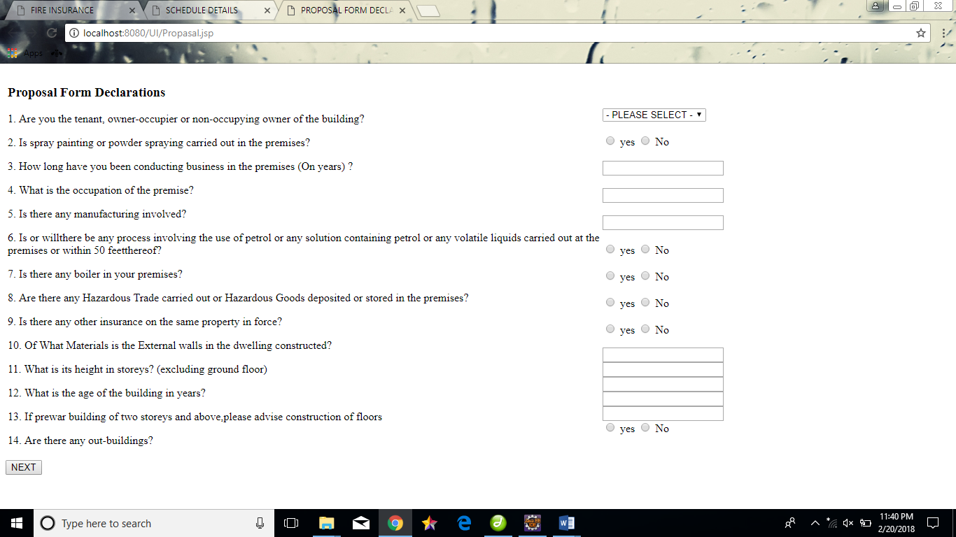

**Premium.jsp**

<%@ page language=*"java"* contentType=*"text/html; charset=ISO-8859-1"*

pageEncoding=*"ISO-8859-1"*%>

<!DOCTYPE html PUBLIC "-//W3C//DTD HTML 4.01 Transitional//EN" "http://www.w3.org/TR/html4/loose.dtd">

<html xmlns=*"http://www.w3.org/1999/xhtml"*>

<head>

<meta http-equiv=*"Content-Type"* content=*"text/html; charset=iso-8859-1"* />

<title>PREMIUM DETAILS</title>

</head>

<body>

<b>PREMIUM DETAILS</b><br>

<form id=*"form1"* name=*"form1"* method=*"post"* action=*""*>

<form id=*"form1"* name=*"form1"* method=*"post"* action=*""*>

<table width=*"1174"* height=*"341"* border=*"0"*>

<tr>

<td>Sum Insured[A]:</td>

<td><input type=*"text"* name=*"textfield"* ng-model=*"SumInsured"*/>

</td>

<td >Basic Premium:</td>

<td><input type=*"text"* name=*"textfield9"* ng-model=*"Basic"*/>

</td>

</tr>

<tr>

<td>Construction Class %:</td>

<td>

<input type=*"text"* name=*"textfield2"* ng-model=*"Construction"* /></td>

<td>RM: </td>

<td><input type=*"text"* name=*"textfield3"* /></td>

</tr>

<tr>

<td>PCW Premium:</td>

<td> <input type=*"text"* name=*"textfield10"* ng-model=*"PCW"* />

</td>

<td>Annual premium :</td>

<td><input type=*"text"* name=*"textfield4"* ng-model=*"Annual"* />

</td>

<tr>

<td>Stamp Duty: </td>

<td>

<input type=*"text"* name=*"textfield5"* ng-model=*"Stamp"* />

</td>

<td>Discount:</td>

<td> <input type=*"text"* name=*"textfield12"* ng-model=*"Discount"* />

</td>

</tr>

<tr>

<td>GST :</td>

<td>

<input type=*"text"* name=*"textfield6"* ng-model=*"GST"* />

</td>

<td>

Total Premium Payable:</td>

<td>

<input type=*"text"* name=*"textfield13"* ng-model=*"Tot_Premium"* />

</td>

</tr>

<tr>

<td>Commission: </td>

<td>

<input type=*"text"* name=*"textfield7"* ng-model=*"Comm"* /></td>

<td>GST on Commission :</td>

<td><input type=*"text"* name=*"textfield14"* ng-model=*"GST_Comm"* /></td>

</tr>

<tr>

<td>Net Premium Payable:</td>

<td>

<input type=*"text"* name=*"textfield8"* ng-model=*"Net_Premium"* /></td>

<td> Gross Premium:</td>

<td><input type=*"text"* name=*"textfield11"* ng-model=*"Gross"* />

</td>

</tr>

</table>

<p>

<label>

<input type=*"submit"* name=*"Submit"* value=*"Back"* />

</label>

<label>

<input type=*"submit"* name=*"Submit2"* value=*"Save"* />

</label>

<label>

<input type=*"submit"* name=*"Submit3"* value=*"Generate and print Question"* />

</label>

<label>

<input type=*"submit"* name=*"Submit4"* value=*"Convert to Covernote"* />

</label>

<label>

<input type=*"submit"* name=*"Submit5"* value=*"Cancel"* />

</label>

</p>

</form>

</body>

</html>

**SCREENSHOT:**

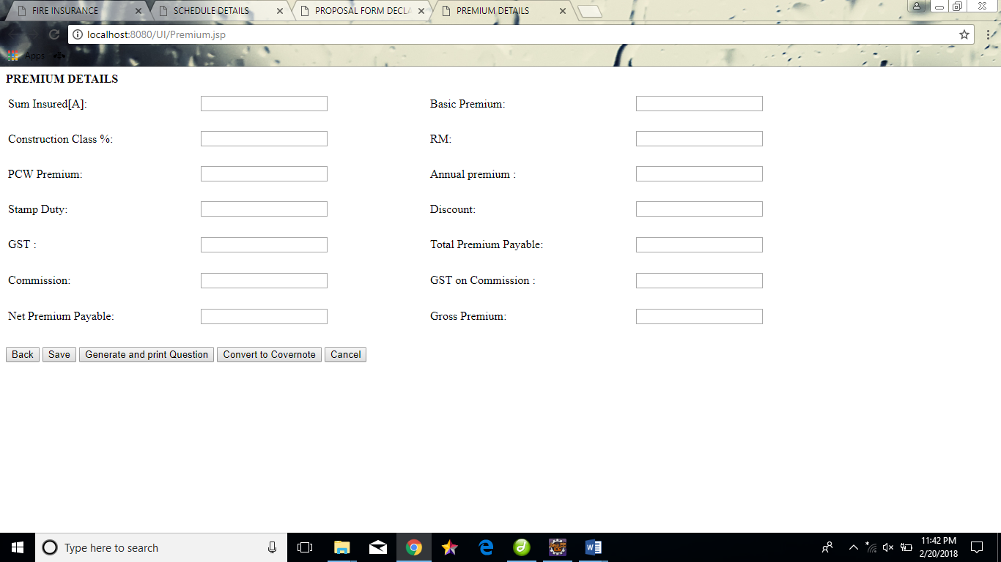

**Receipt.jsp**

<%@ page language=*"java"* contentType=*"text/html; charset=ISO-8859-1"*

pageEncoding=*"ISO-8859-1"*%>

<!DOCTYPE html PUBLIC "-//W3C//DTD HTML 4.01 Transitional//EN" "http://www.w3.org/TR/html4/loose.dtd">

<html xmlns=*"http://www.w3.org/1999/xhtml"*>

<head>

<meta http-equiv=*"Content-Type"* content=*"text/html; charset=iso-8859-1"* />

<title>RECEIPT</title>

</head>

<body>

<p><strong><h3>RECEIPT ENTRY - NEW BUSINESS</h3></strong></p>

<p><em><strong><h4>PAYMENT DETAILS</h4></strong></em></p>

<form id=*"form1"* name=*"form1"* method=*"post"* action=*""*>

<table width=*"1051"* height=*"175"* border=*"0"*>

<tr>

<td>Payment Mode :</td>

<td><select size=*"1"*>

<option selected=*"selected"*>Credit</option>

<option>Debit Card</option>

<option>Net Banking</option>

</select>

</td>

<td>Cheque/ Direct Bank in Slip No:</td>

<td><input type=*"text"* name=*"textfield"* />

</td>

</tr>

<tr>

<td>Source Bank :</td>

<td> <select name=*"select2"* size=*"1"*>

<option>INDIAN BANK</option>

<option>SBI</option>

<option>RBI</option>

<option>CANARA</option>

<option>KVB</option>

</select>

</td>

<td>Source Bank Branch :</td>

<td><select name=*"select5"*>

<option>-SELECT-</option>

<option>kolalampur</option>

<option>aaa</option>

<option>bbb</option>

<option>ccc</option>

</select>

</td>

</tr>

<tr>

<td>Deposit Bank Code:</td>

<td>

<select name=*"select3"* size=*"1"*>

<option>322</option>

<option>322</option>

<option>8086</option>

</select>

</td>

<td>Cheque / Pay in Slip Date :</td>

<td>

<input type=*"text"* name=*"textfield2"* />

</td>

</tr>

<tr>

<td>Payment Gateway :

<td>

<select name=*"select4"* size=*"1"*>

<option>BANK</option>

</select>

</td>

<td>Total Amount :</td>

<td>

<input type=*"text"* name=*"textfield3"* />

</td>

</tr>

</table>

<p>

<label>

<input type=*"submit"* name=*"Submit"* value=*"Add"* />

</label>

<label>

<input type=*"submit"* name=*"Submit2"* value=*"Remove"* />

</label>

</p>

</form>

<form id=*"form2"* name=*"form2"* method=*"post"* action=*""*>

<table width=*"527"* border=*"0"* bordercolor=*"#00CC99"*>

<tr>

<td width=*"303"*>Payment Mode </td>

<td width=*"208"*>Amount Paid </td>

</tr>

<tr>

<td>Cash</td>

<td>69.34</td>

</tr>

<tr>

<td>&nbsp;</td>

<td>&nbsp;</td>

</tr>

<tr>

<td>&nbsp;</td>

<td>&nbsp;</td>

</tr>

</table>

<p>

<label>

<input type=*"submit"* name=*"Submit3"* value=*"Back"* />

</label>

<label>

<input type=*"submit"* name=*"Submit4"* value=*"Submit"* />

</label>

<label>

<input type=*"submit"* name=*"Submit5"* value=*"Print"* />

</label>

<label>

<input type=*"submit"* name=*"Submit6"* value=*"Cancel"* />

</label>

</p>

</form>

<p>&nbsp;</p>

</body>

</html>

**SCREEN SHOT**

